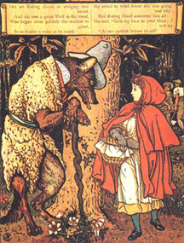
Grimms’ Fairy Tales
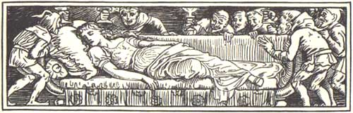
Illustration by Walter Crane for ‘Snow White’ (1882)
The Brothers Grimm were Jacob and Wilhelm Grimm, German professors of linguistics, who became best known for collecting folk and fairy tales.
In the course of their work on linguistics which included an analysis of how words change their sounds over the course of time, they found that one of the best ways to get older people to talk to them and share the sounds of their dialects was to ask them to tell the stories that had been passed down to them. The brothers kept a record of these stories and eventually published them in 1812. They followed this with an update in 1814.
The Grimms’ collection of tales consists mainly of Germanic tales but includes a number of French tales as well. The stories were not intended primarily for children. They contain witches, trolls, goblins, and wolves who prowl dark forests. Some of the tales were quite explicit and were rewritten by the brothers to better reflect what was considered appropriate for their time. Many English translations exist, but most of these are attempts to make the stories into harmless entertainments for children. The original tales are often very dark and do not make any attempt to avoid frightening their listeners, regardless of age.
The tales collected by the Brothers Grimm underlie much of what we are familiar with today in children’s literature and cinema. The entire history of the Disney company is a major example of the Grimms’ influence beginning with the company’s first animated feature film, ‘Snow White and the Seven Dwarfs.’
The tales are a magical, scary, comedic, and often violent journey into the forests of ancient Germany and France where every path leads to mystery and adventure.
CONTENT NOTICE:
Grimm’s Fairy Tales are not all appropriate for very young children. Some of the tales contain violence and prejudice. Unfortunately, they do reflect some of the less admirable qualities of the people who told the tales and spread them from one region to another. Some of the prejudice in evidence still exists today and cannot be viewed as entirely historical in nature. Quite frankly, there are some great things about these tales, but their antisemitism and racial hatred is just absurdly evident. Germany was quite obviously headed down a terrible road much earlier than is often supposed. Please exercise care when reading these stories to young children.
In the box below, record four to 6 main points from the article.

