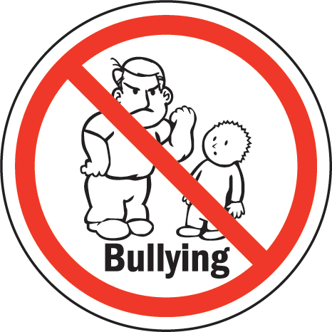
Bullying terms
Bullying is deliberate and repeated hostile behaviour intended to harm others. It involves the misuse of power by an individual or group towards one or more people. It can include direct or indirect insults, remarks, physical abuse and/or social exclusion. All forms of bullying can have long-term social, academic and/or psychological effects on all involved.

re·sil·ience (noun)
1. the power or ability to return to the original form or position after being bent, compressed, or stretched; elasticity.
2. ability to recover readily from illness, depression, adversity, or the like; buoyancy.

Bully: the person/people responsible for the bullying behaviour.
Target: the person/people who is/are the target of the bullying behaviour.
Bystanders: individuals who witness the bullying behaviour. Bystanders can act in many different ways. They might:
- watch what is going on and not get involved.
- ignore the situation.
- choose to get involved in the bullying.
- choose to get involved and stop the bullying.
- choose to get help.
Trusted adult: an adult whom the bully, target or bystander can talk to about the bullying behaviour. This person may also be able to help stop or rectify the bullying behaviour.
Types of Bullying
Bullying may be:
- verbal – name-calling, put-downs, threats
- physical – hitting, tripping, poking, punching, kicking, throwing objects, stealing
- social – ignoring, hiding, ostracising (leaving someone out on purpose)
- psychological – stalking, dirty looks, spreading rumours, hiding and/or damaging possessions.

