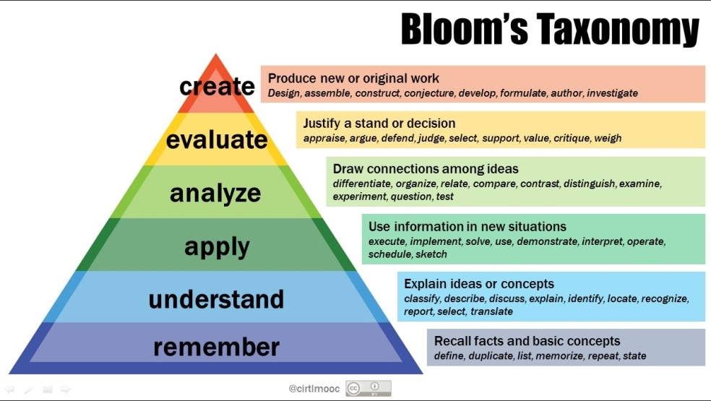
New Boy by Steph Green
My message to you…
In this worksheet we will work with Bloom’s taxonomy. As you know, you need to be able to function at the lower levels of the taxonomy in order to reach the higher levels.
Work through the questions below. Your goal is to work as far up the taxonomy as you can, aiming for your personal best and nothing less.
- It is not a speed test.
- Answer in full sentences to improve your expression.
- Answer fully, adopting the voice of a teacher who must teach a student when you answer.
1. | Who is Joseph and where is he from?
2. | How would you describe Joseph’s new teacher?
3. | How does the teacher discipline the children?
4. | What do the maths exercises remind Joseph of?
5. | How does Joseph react to Christian Kelly bullying him in the classroom?
6. | What happens to Joseph in the playground? Give details in your response.
7. | What do you think happened to Joseph’s father?
8. | Why do Joseph, Christian and Seth end up laughing together?
9. | What does the end of the film suggest about Joseph’s future at the school?
10. | Does the film have a message? What do you think it is?
11. | Who is the ‘target’ in the story?
12. | Who is the bully?
13. | Which of the roles you have learned about is played by the teacher?
14. | What is the theme of the story?
15. | What is the central conflict of the story?
16. | How does the film maker show us Joseph’s background?
17. | How does the film maker suggest to the audience what happened to Joseph’s father?
18. | Evaluate Joseph’s solution to the problem. What is your opinion of his solution? Explain giving good reasons for your opinion.

