Writing poetry about discrimination
You have been asked to include a poem on your anti-discrimination website.
Poetry is language at its purest. We remove all the words and ideas that are not necessary. One of the ways we can do this is through blackout poetry.
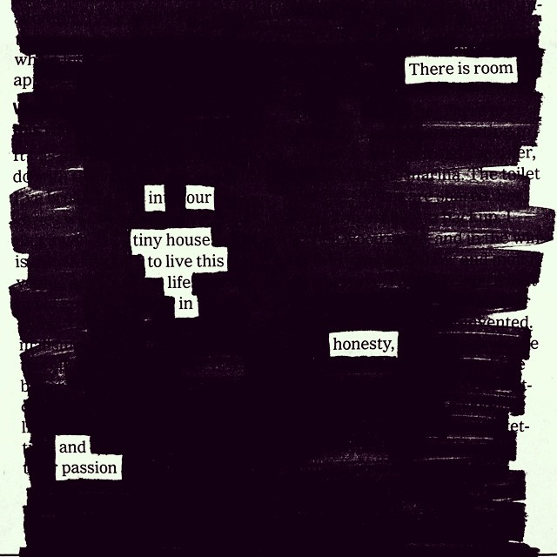
SAMPLE 1
Sample 1 looks like a simple statement but it could also be a metaphor for tolerance. What if the “tiny house” is our country or our planet and this poem is really saying, ‘There is room in the world for everyone to live well’.
SAMPLE 2
Sample 2 makes you really think about what the poet might really mean and the illustration at the bottom is also really effective.
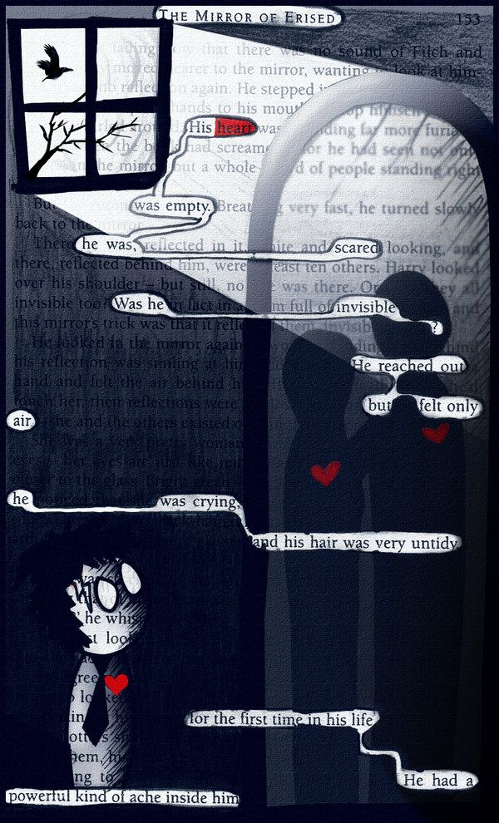

NOW IT’S YOUR TURN
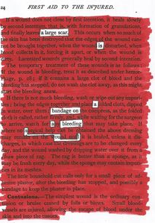
You can use Sharpies, pencil, texta, etc to make your own blackout poem that conveys an idea about discrimination or explores the feelings of those who have been discriminated against. Your poetry could be coloured or monochrome.
THE RULES
- Make it meaningful and thought-provoking
- Try to make a statement that can be read as a metaphor for an idea about discrimination.
- Make sure the reader can read it (reading path)
- Plan before you black out.
- Be careful removing the book page. You don’t want to tear it.
- Create a poem you can be proud of.
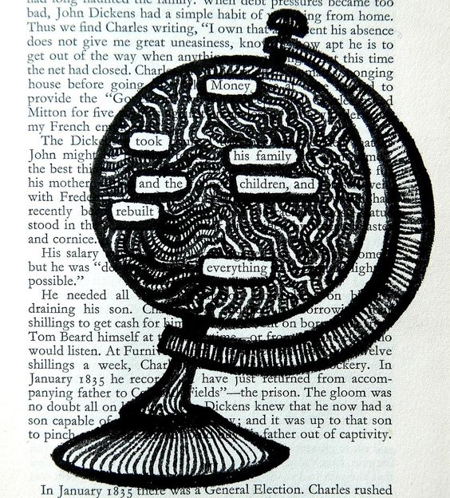
Below are some more samples to help you out. When your poem is finished, photograph it so you can add it to your web page as an image. If you do not have the technology, I can do this for you.
